Store Sale Prediction with Data Science

Name: AFZAL HUSSAIN
UB: 20029043
DR OLUSOYI RICHARD ASHAYE
Thesis

Chapter # 1 Introduction
Machine learning algorithm would be help for sales forecasting which is essentially used for sales forecasting, machine learning algorithm discover the factor that influence sales in retail store and estimate the number of sales in the near future. In this research historical sales data of Rossmann stores chain is used to predict its sales upto one week in advance by using the advance machine learning and deep learning programing algorithm. This research present the data analysis of various retail store chain by using the dataset which contains the dataset of different attributes of values, KNN algorithm predict the neighbor sales store forecasting graph that present graphically to view the different retail chain stores. Since the support vector machine classifier presents the best regression prediction comparatively to KNN algorithm and SVM classifier is best classifier algorithm of machine learning to discover the sales forecasting of Rossmann stores chain at Europe cities. In order to improve the sales forecasting graph this research is going to present the weather or weekdays or weekend’s results are suitable for real situation. This research present decision tree, artificial neural network classifier, support vector machine classifier algorithm mechanism in contrast of numerical experiences by using the dataset which is used from Kaggle repository. Experiment results show that the support vector machine classifier algorithm presents the best classification method and decision tree present the tree of daily forecasting sales of various retails store chain at Europe. Beside this artificial neural network works together with decision tree algorithm classifier which presents the daily sales forecast. Customer predictive analytics technique with support vector machine classifier and plotly, customer behavior and demographics has unlocked the world of possibilities for digital marketing strategies which utilizing the predictive analysis, various marketing and management strategies applicable for future forecasting sales and it also used to estimates the different data analytics technique by means of advance one week sales. Support vector machine classifier would be used to increase the understanding of different retails store chains by means of Rossmann stores at different locations, stakeholders wants to renovate the stores and wants to predict the advance one week sales including weekdays and weekend it was also mentioned that black Friday sales also estimated in advance one week future forecasting sales, various research takes participate at the past which is being part of data science and artificial intelligence method.
The modern customer categorized by their demand and control for connectivity and convenience, the increasing of global marketplace by means of advance sales with online order booking and convince payment plans. Customers and sales representatives evaluation analyzed with sentiment analysis of machine learning method which used by the machine learning discovery method. The modern customer looks to review by their opinion of other people including emotional review which could be used to make and brand the product. Modern customer sales concept constructed on modern technology data analytics method which boost the retail sales store sales as well and make them to be able to analyze the future sales discovery. Recent research present that the Alexa is going to be automatically delivering to us fresh box of tissues a day before we run out based on data about flu outbreaks around the world. The frequency of flue sneeze which recorded when the listening wrote has been predicted and analyzed them. In python programming the exploratory data analysis used with Plotly library of machine learning algorithm which comes to be the modern data analysis method in the era of sales prediction technique. The primary objectives of this research to validate the primary variable of Rossmann retail store chain at different items of interest it included on binary variable that represents whether the customer responded to marketing call either or not. Since the factor of sales channel renew the offer type which quickly perform the descriptive analysis that taking the advantage of machine learning discovery technique.
In several supply chain the ability to accurately predict the sales which direct the impacts on its operating expenditure. Beside this the ability to predict and evaluate the future variables of various retail stores of Rossmann stores at different location of UK. The good understanding of machine learning discovery which enables the stakeholders, Rossmann stores operates over 3000 drugs stores in 7 European countries, recently the Rossmann store handle and manage the various tasked of predicting their daily sales for upto six weeks in advance sales forecasting which eventually beneficial for the stores renovation and other expenses of store sales, stores sales effects by numerous issues including promotions, competition and school holidays with seasonality and locality. Various thousands of individual managers has been works together to predict the future sales and accuracy results evaluated on different future forecasting mechanism. Linear regression models used the optimal ordinary least square optimization to fit the polynomial of degree by using the dataset of different variable and various attributes. In literature review section presents the different machine learning and linear regression algorithm which based on support vector machine classifier, logistic regression and decision tree algorithm. And the results and analysis chapter of this research also used these machine learning algorithm which founded on different scales and parameters.

Aims & Objective

The aim and objectives of this research is to predict and validate the machine learning future forecasting sales prediction which constructed on different linear regression algorithm. Building the decision tree classifier to predict the daily forecast sales of Rossmann stores beside this support vector machine classifier algorithm used to predict and analyze the mapping functions to map the seemingly nonlinear dataset by use of kernel tricks. Various hyperplanes and limitation models used to predict and analyze the factor of sales analysis, limiting the model parameters to support vector which contribute the maximizing the margins. Because the label is the real number which eventually validate the numerical data variables corresponding to training and testing the dataset and building the model which based on linear regression and logistic regression analysis and support vector machine and decision tree classifier. The main goal of this research is going to predict the future forecast of advance one week sales of Rossmann store sales.

Dataset and Features
Dataset provided from Kaggle repository which is used to evaluate the features of sales by training and testing the dataset. The feature of dataset is used with different items of sales interest of different chain of Rossmann drug store. Sales data target variable of every store is provided along with various features like distance of nearest neighbors competitor store including promotional activities and number of customer sales name with different attributes of records. Dataset is based on mix set of continuous and discrete variables. Training dataset was done on different retails stores resulting in one prediction model based on daily basis sales and weekly basis sale. The features competition of retail store of different chain resulting in the direction of different prediction sales model. The four features are used for training the dataset which is eventually selected on parameter of week, month, and publicity action including public and school holiday. Sales dataset quantify with quantitative statistical analysis which founded on predicted the values of various drug store attribute. The feature vector at time t selected on various features of machine learning classifier algorithm, the prediction analysis method propounded on feature selection of monthly sales and selection of store variable form dataset and the research target variable is going to predict the upcoming week sales forecasting based on the dataset. Preprocessing consist of two stages which calculates the minimum records of sales and beside this the second part is going to calculate the subtracted data from the sales results which making the zero and maximum results. Histogram of the sales data present the validation of various features selected on different attributes of dataset. The second stage quantize the sales data into discrete quantization levels of various week variable.
The following method has been used in this research as follows:
- Linear Regression
- Support vector machine classifier
- Random forest tree
- Artificial neural network decision tree
- KNN algorithm

Research Challenges (Summary)

Support vector classifier is part of support vector regression classification technique which part of different sales items of interest. The main objectives of functions constraint are similar with support vector machine classifier algorithm the validation process comparatively to artificial neural network decision tree which forecast the daily retail sales forecast which construct the future selection as well. The parameters of decision tree classification are fixed which does not reflect on the change and the objective functions constraint validate the parameter of several different kernel functions perform the linear separation classification technique. By implementing these algorithms random forest works the best and provides the reliable prediction of the retail store sales future sales prediction. SVM uses the Gaussian polynomial kernel and RF with polynomial least square functions. The fact shows that the validation process calculate the reasonable prediction by use of dataset. The Gradient boosting algorithm founded on K-nearest neighbor algorithm which calculates the different pattern of nearest neighbors stores locations and store sales nearest neighbors sales which required by the stakeholder. The functionality of variables of interest propounded on different parameter & strategies. The future challenges of XG Boost algorithm with ARIMA model prediction remained challenging part of the prediction of different dataset sales. ARIMA model was not able to capture the nonlinear pattern. The auto regression neural network models including hybrid model of XG Boost algorithm does not predict accurately. The decomposition of forecast sales predict on different features of interest which validate the resultant values based on the different parameters of algorithm. Since all the identical competition of Kaggle present the real world particular context with different selection criteria since the time series validation predict the different data times on different scales and parameters of interest which always concerned on challenging consumptions. Sales forecasting using the multivariate long term and short term memory network models. The comparison results of linear forecasting method and resultant with gradient boost algorithm and KNN classification technique which reflects on different points of K values and neighbors graphic show the different retails items on demands. Random forest regression model further improve the prediction accuracy results which incorporate the features analysis that explored on daily drugs sales which founded on decision tree classificiaon parameter, but the limitation is still challenging by using the deep learning models of decision tree algorithm, support vector machine learning algorithm performs better than other regression models the future forecast models by using the graph structure and exploratory data analysis which presents the different store sales items of interest that calculate and predict the values of upcoming future research values. The outcomes is still remaining to produce the upcoming sales of different 1000 of drug sales but the precision call and accuracy score might be different because of different length of dataset might be reflected on various attributes of interest. The objectives of dataset produced the great outcome to calculate the validation set and prediction set of current research and future research. The KNN algorithm does not produce the highest accuracy it only present the K mean graph to show the nearest locations of drug store. Rossmann store classification tested previous by various researcher but the needs of improved outcomes with great sales in one week prediction required by the stakeholder, because they wants to invest in the sales prediction to invest in different store sales in the given dataset.

Chapter # 2: Literature Review
The purpose of this literature review is to examine the store sales prediction by implementing machine learning models. Literature review is part of secondary research data by implementing the review of stores sales and future sales trends and market strategies.

Related Work

Most of the business organization deeply depends on the information based request prediction of sales trends. (Cheriyan, S., Ibrahim. 2018), getting the sales trends accuracy forecast provides large influence in corporate. Data mining and machine learning method is useful technique to mine the concealed information. The comprehensive details models to enhance the data models prediction founded on various strategies, predictive models to improve future sales and big data forecast to measure and evaluate the future trends, this research analyze the sales forecast and future trends and the issues overcome to compare the future trends values of sales forecasting, prediction and forecasting based on Gradient Boost algorithm which present maximum accuracy in forecast. (Yada, K., 2016) deep learning approach to predict the retail store sales and estimate the future sales trends by presenting machine learning models, studied uses three years’ worth point of sales predict the sales models using the sales of specific time, resultant deep learning models consider L1 regularization attained sales estimating degree of 86% and the product retail sales has been recognized by implementing the product category, suggest in this research deep learning higher prediction models to predict the future sales trends. (Tsoumakas, G., 2019) machine learning methods to predict food sales calculation estimating the future sales calculation based on food industry, supermarket, groceries, restaurant and bakeries and short term prediction businesses permits corporations to diminish supplied and died invention and circumvent absent auctions this research build machine learning models for food sales prediction validate on various sales technique. Data scientist works on food sales prediction with temporal regulatory of sales data by input the variables (Choi, J. Oh, H., 2021) sales store estimation designed by gradient boosting models the rapid development of machine learning has been developed diverse applied method not for daily life also for industrial zone. By using financial data of stores to design and predict the use case of store sales, machine learning method used to store sales data, and present future applications for fintech enterprises, missing data values also examined by implementing gradient boosting method algorithm such as XGBoost, LightGBM, and catBoost to examine the future trends and examined the future income of separate stock. Store would be taking benefits by implementing sales trends and revenue trends by receiving the assistance of future revenue to predict and examines the roles of stores and sales of different product category. (Pavlyshenko, B.M., 2019) time series forecasting of dataset to predict the sales and market trends with machine leaning modeling method, machine learning models for sales predictive analysis for building machine learning sales forecasting by using the small amounts of historical data for particular time series forecasting evaluation and validation of using the time series regression algorithm to predict future sales trends, neural network classification method and linear models extracts the multivariate time series data to view and extract the knowledge driven approach. The aggregated target variables using the R scripts eventually build the machine learning models by plot the dataset and view and examine the sales trends of various groceries stores, the effect of capturing whole sets of data choosing the optimal number of iterations, repeat the future trends. (Kohli, S. Urolagin, S., 2021) sales forecast using the linear and KNN regression, sales prediction always taking complex to validate the exact outcomes because lack of missing data and blank values exists in dataset, data cleaning and data optimizations is another challenging issues to extract the knowledge to mine the dataset. Sales prediction is more often to takes the challenges of complicated pattern of dynamic sales by using the supervised machine learning technique. Dynamic values included to evaluate the sales prediction forecasting method to examine the complicated sales pattern which was founded on dynamic variable rules. Sales forecasting plays significant roles in the building of organization success due to experience of past datasets and future market trends of sales with revenue estimation. Sales prediction models often used by the organization to takes decision and validate the future revenue trends and make better knowledgeable decision, linear regression models founded on KNN regression, sales forecasting would be beneficial for the sales organization to examines to save money for better planning of future and increasing the profit earned. It was important to note that for deploying machine learning models by using the statistical method RMSE and MAPE, the resultant outcomes based on suitable classifier of sales prediction.
(Sharma, S.K., 2019) analysis of book sales predictions at amazon marketplace in India by implementing the machine learning based approach, it predict the customer book demands on different price variations and author variations supply chain management helps to count the supply and demands of books reduces the delivery time with cost estimation in context of e-commerce calculations which is predict the customer demands captured by sales volume for implemented the analysis of multi factor which is founded on type of product, country, purchase, price discount rate and delivery date estimated on machine learning method. Amazon book sales predictions was estimated on machine learning algorithm which was based on logistic regression, decision tree analysis and artificial neural networks for predicts the sales of neural networks hidden neurons pattern. Sentiment analysis has been carried out by using the online review method which predict the sales forecast and market trends observation on different business scenario. It is necessary to understand that the business modeling has been predicted and analyzed, machine learning modeling has been used in previous business dataset to analyze and predict the dataset. Since the worker efficiency measured and analyzed on parameter of human resource management and the planned of accuracy detection has been verified and updated on demands of data items. Sales and marketing department using the artificial intelligence algorithm to produce the highly results in influence of sales data items of interest. After training the dataset the outcomes present the feature analysis of sales data which highly depends on the organization period. (Ramasubbareddy, S., Srinivas, 2021) sales store and retail store prediction has been estimated and analyzed on different time variations of dataset, dataset has been analyzed and predicted on different parameters of business surplus. Business intelligence technique has been analyzed and predicting on business data interest in which different parameters of data and sales data. The future forecasting has been analyzed and predicted on different time scales pattern.
(Ramasubbareddy, S., Srinivas, 2021) sales surplus data items interest physically maintained on business intelligence methods, the method of data predictions and data analysis has been made to do the various analysis, forecasting of big mart sales using optimized machine learning technique, the store sales prediction measured and analyzed machine learning deep learning models, neural networks models produced the highest results to obtain the better accuracy of results. Data mining technique also implemented for knowledge extraction and variable selection, and deploying the machine learning algorithm which was essential tools to obtain the better outcomes of past sales data and present sales data and analyzed the cash surplus , profit calculation , measured the different time summary in which different items of interest has been carried out. Sales data prediction calculate on feature selection and variable selection of data items of interest, various data items of interest has been carried out implemented. Machine learning algorithm deploying deep learning algorithm which was essential tools to analyze and predict the different time frequency of various sales data items. Machine learning modeling analyzed the profit surplus on daily cash flow of business, it was also applied the monthly sales profit on different demands of product. The variations of dataset and data items in which different class observations and class variable has been implemented. Machine leaning in predicting demand for fast moving consumer good in exploratory research, this article uses the (E Tarallo, 2019), consumer goods moving and processing on different time series variations, the class of data items has been measured and analyzed the class observation parameters of dataset. The results of this research show that Machine learning methods, counting the newest approaches such as Deep Learning, as well as utilizing the best approach of predicting the daily sales data forecasting and count the cash surplus on different variations. Machine learning predict the historic sales data in which difference product items of interest, various product items categorized and selected on different parameters of classification of algorithm technique. Machine learning modeling method has been used to produce the better outcomes of the result, the better ways to analyze the performance analysis in which different times classification of interest, sales price and profit calculation estimated and predicted separately which has been essential ways to producing the better outcomes. The features selection of dataset analyzed and predicted on different classification method parameters of interest, the regional mart dataset variation calculation on different classification technique in which various data items of interest has been estimated and calculated.
(E Tarallo, 2019), machine learning method analyzed on monthly sales items forecasting of interest on different parameters of interest, machine learning classifier models build the better outcomes of data items of interest. (Remagnino, P., 2018) embedded deep learning method for person detection, the complex model prediction of person detection to obtain the great accuracy followed by the implementation of deep learning algorithm, person detection is very common approach in deep learning and computer vision field which was essentially implemented in retail stores to predict the person to person sales and product item selection, the image categorization and image classification technique has been eventually used to solves the complex computer vision problem, person detection in retail stores the optimal solutions of person detection the retail sales has been carried out by implementing of deep learning facial recognition method, in real time person detection approach successfully works to capture the customer in real time to detect the person purchasing and retail consumptions. Person detection by implementing the neural network based approach to capture the hidden layers classification method, to detect emotion of various person identification and detection to meet the criteria of person identification and product classification, operations of YOLO, SSD, RCNN, R-FCN and SqueezeDet have been measured by our in-house branded dataset which contains of ended 10 thousands inside imageries took procedure shopping malls, retails and stores. Investigational results designate that, Tiny YOLO-416 and SSD (VGG-300) are the wildest then Faster-RCNN (Inception ResNet-v2) and R-FCN (ResNet-101) remain the greatest precise sensors examined in this learning. (Logofatu D. (2021) analysis and prediction of sales house prices which founded on different hybrid machine learning approach, machine learning plays pivot roles in business industry, the image recognition and spam detection automatic secure applications of secure automobile services, this research analyze price prediction of different product items by implementing the machine learning algorithm feature extraction, data preparation, model selection, model training, and optimization of dataset prediction and evaluation of stores items carried out on monthly forecasting sales and present this report at the end of month to CEO of corporate store. Experiment algorithm founded on linear regression, random forest and gradient boosting, these algorithm helps store sellers and customer to have fair price deal in respective retail store sales business, various store to stores sales items has been identified and predicted on machine learning models. (Byeonghwa Parka Jae KwonBae 2015) in Virginia sales store prediction has been carried out to implement and deploying the sales prediction of stores on different variable of sales product interest. Refection of different items sales interest measured on different pattern of machine learning algorithm machine learning model ADA Boost and naïve bays classifier predict the store sales and product count, daily product count analyzed on different time frequency based analysis. Prediction of product measured on different machine learning count parameters which was essentially different from analyzed schemes of time series floating point parameters, data cleaning and data preprocessing method has been used to implement the regression classifier algorithm, US state sales store various null values found in the given dataset, and various blank values also found, so there is need to clean the dataset. Model performance and model accuracy has been implemented to validate and predict the product classification on different parameters. (Parasich Viktor Aleksandrovich 2018) using the regression method of analysis describe the advance price prediction technique, the participation observation dataset has been collected on different mart stores and the observation has been calculated and measured on different time scales parameters. The participant explores various approaches on behalf of time frequency domains.
(Behera, G. Bhoi, A., 2021) Univariate Holt winter store sales forecasting retailing type under investigation to proceeds the sales product forecasting in each month prediction which created on profit and loss homogenous and comparison based in 86 realization prediction method proceeds from January 2010 to January 2017. To achieve near incomes this research the ARIMA model and exponential smoothing methods are used in this research, additionally the model fit measures may be exploited in the optimal model building and the result has been extracted by applying the HOLT WINTER seasonal method in two store large scale scaling types, evaluation of persisting increasing trends and fluctuation around the constant level including seasonal pattern has been predicted from 2010 to 2017 year. Impact of management and marketing trends has been analyzed in this research due to prediction of annual sales store method prediction which founded on the seasonal time series sales forecasting (Vahidov, R., 2008) in collaboration with supply chain technique by deploying the machine learning models, in participant firms, various number of factors in increasing trends and decreasing trends has been analyzed and the forecasting demands analyzed by implementing of present participant and other participant demands, the variation predicted on advanced machine learning method deep learning technique with artificial neural networks layer and recurrent neural networks and support vector machine classifier method and the forecasting distorted demand at the end of supply chain predicted, and comparison of traditional seasonal method including naïve forecasting trends moving averages and linear regression, this research uses two dataset to obtain the experiment results in simulated supply chain method data including Canadian foundries orders based on supply and chain system, at the end of this research suggested that to get the supply and chain outcomes in terms of order sales forecasting to deploy recurrent neural networks machine learning methods to obtain the support vector machine and regression models prediction outcomes (Takenaka, T., 2019) demand forecasting analysis in restaurant by using the machine learning method and statistical analysis, various researchers proposed demand forecasting analysis method using the POS data technology in order the detect the demand forecasting of sales store specific demand forecasting by considering the various factors such as store location and weather events, in this research demand forecasting model functionally mutual the various factors of store location two mentioned data based on machine learning method. The real store data is discussed on demand forecasting method which analyzed on statistical graphs and trends. (Huber, J. Stuckenschmidt, H., 2020) daily retail demand forecasting using machine learning with weight on calendric special days. This research present the case study of bakery chain, with special calendric sales days which demands higher bakery product and the sales forecasting analyzed on daily basis store sales prediction and rest of the other sales happening on weekend’s days and at the end of the month with different product category. The supervised machine learning methods provides the daily tasks analysis constructed on prime store sales which analyzed on daily product sales, machine learning model artificial neural network and gradient booster including decision tree and the possible outlines has been predicted formulating the classification models regression modeling’s and the evaluation of gradient booster which founded on decision tree and support vector machine classification method and these analysis method helps in the bakery sales production and make them in decision pattern. (Zuo, Y., Yada, K. Ali, A.S., 2016) prediction of consumer purchasing in grocery store by using the machine learning technique, consumer sales prediction variation recognized on consumer sales and purchasing behavior, the measure response rates intention in context of customer age, gender and income product price and sales promotion with various business models has been analyzed and predicted in estimation of linear equation to estimate the weight factor which help in the business management plans. However, likening through supplementary research grounds (e.g. pattern recognition and text classification), the forecast approaches aimed at acquisition conduct remain overconcentration of the linear models, particularly linear discriminant examination then logistic regression examination. Beside this communication models used widely by the business management teams to validate and verify the product development in order to verify the sales production method and the examination of business plans management to discriminant of business analysis in volume of increasing data in retail store management, effective machine learning approach implemented in order to validate the store sales prediction modeling. Support vector machine and bays classifier method analyzed and predicted designed on sales promotional dataset. (Pechenizkiy, M., 2012) beating the baseline prediction in sales production using the intelligence prediction, the intelligent sales prediction method predicted and analyzed in various large numbers of factor analysis in breathing sales demands with simple moving averages baseline and properties of historical sales deployed and implemented on non-trivial classify the auctions period sequence hooked on ‘predictable’ and ‘random’ founded scheduled physical, form then interpersonal topographies connected toward the foodstuffs and the setting by meta learning approach. The identified sales production item sales analyzed on demands frequency approach to validate and predict the daily forecasting analysis as well which needs more classification pattern to predict the store sales item of interest by deploying the gradient boos method of machine learning approach.(Güven, İ. Şimşir, F., 2020) demands forecasting with color parameter in retail apparel industry using the artificial neural networks including support vector machine classifier method and the approach apply on large dataset and color variable which founded on string input designed on ANN and SVM, in retail garment industry in context of machine learning method to established the inference product category presented in different colors schemes to inference of dataset modeling and nine different production estimation has been captured and analyzed which consist of product category and combined the results to add the proposed model prediction. ANN and SVM method of machine learning approach analyzed the dataset including different product categories and examined the outcomes with increasing number of sales forecasting with experience proposed models. Therefore 20 dissimilar replicas remained recognized and associated. Lengthways through hue part, additional variables that may consume a result on the auctions presentation such as weather, gender, singular existences etc., consume remained additional toward future replicas. Happening the contrast of approaches origin mean square fault has been taken into thought. By way of a consequence of this research, the situation has been resolute that ANN outdid SVM on seven datasets available of ten for the datasets deprived of color and their presentations remained smooth aimed at the datasets through color. (Silva, L.F., 2018) the use of deep neural networks approach in fashion sales store, the sales forecasting analyzed by deploying the shallow neural networks method and the predicted variable were developed in various distribution series. Fashion store sales product satisfy the customer requirement on various variations of fashion product items and offer discounted price on available extra stocks the profit surplus estimated by examining the additional stock including demand forecasting of sales items based on discounted price which additionally facilitate the customer to takes interest for buying the fashion product. The historical data has been collected on various database system of product items by deploying the deep learning approach in prediction of sales product new and individual product in future sales prediction. The fashion retail company purchasing features predicted and analyzed in real dataset provided by the fashion store and compare them with other databases of fashion store, the diverse set of variable has been selected from the given dataset, and data preprocessing operating carried out then feature selection of dataset has been selected. After cleaning the dataset to fulfill the desired missing values in the dataset deep learning models applied decision tree, random forest, support vector regression, artificial neural networks including linear regression model present the performance sales analysis in fashion retail sales marketing, additionally the emulation metrics is considered and it does not perform the significant technique in random forest method.

Conclusion of Literature Review (Summary)

Store sales prediction method analyzed and predicted on various machine learning and deep learning approaches, support vector machine classifier and logistic regression models present the sales forecasting and time series data analysis in view of taking sales and promotional decision. The organized deep learning approach also discussed with decision tree, random forest tree, and linear regression models including artificial neural network approach. Supervised machine leaning gradient boost method with KNN regression by using the store sales dataset. Method of this research is going to deployed machine learning and deep learning algorithm as follows:
- SVM MODEL, linear regression model
- Logistic regression models
- ANN neural networks with gradient boost method
- KNN REGRESSION model
- Decision tree deep learning

Chapter # 3 Methodology

Introduction
Store sales prediction method designed on machine learning and deep learning method, quantitative research method used in this research based on statistical and data mining technique. Statistical technique formally designed on machine learning models, retail stores sales prediction, mart sales prediction and various other sales store prediction has been analyzed and predicted founded on various financial surplus profit and loss calculation strategies. Machine learning prediction used to increase the store sales and it provides the complete interface of business strategies with planned outcomes of various business management sales management and marketing plans. Machine learning models interface of business solution which calculates the future finance and estimate the product sales on daily basis and monthly basis, it’s also highlights the demands products sales forecasting in which the product items is of interest for consumers interest.

Research Philosophy
The evolution of retail stores covering hundreds of years of bartering and peddling in single bound. The impact of retail stores provides the positive impacts towards the public community due to every spends of life is there. The concept of retail stores start about in 18th century with the name of “mom” and “pop” store is a colloquial phrase for a small family owned independent business. During the 18th and 19th century the concept of retail stores spreading all over the unites states rapidly by growing the public demands interest. During 18th century people plans to settle their lives in town and preparing a planned town over the Unite States locations. It remained not unusual aimed at both urban to consume a mom and pop stock contribution over-all merchandise that could be bought on behalf of everyday lifetime. In 1930 farmer exchanges animals to introduce the first shopping mall it’s been interesting evolution landmark of that time. Trade remained gradually substituted by way of a development produced with trade, which complicated the usage of moneys. The situation remains expected that the idea of procurement besides vending remains instinctive in Asia Slight, which remains today’s Turkey about 7th time BC. The ancient public market introduced in Babylonia and Egypt for purchasing of goods in return of gold and animals. Market operated in Arab countries without currencies, buying and selling of goods possible with exchange of something other products which was very beneficial for the public. They also imported oil, nuts, wine and fruits, textile, woods which become major trading power in 9th and 10th century BC. Happening about the time of 1500 BC, they established a script that finished the situation abundant calmer toward comprehend then catch the multifaceted writings which remained recycled in Mesopotamia and Egypt. Scheduled the additional pointer glowing the indicator proprietors accomplish towards issue scheduled their individual, then the situation might consume complicated introducing besides spreading. Roman always used preferred purchase their goods on specific places such as cinnamon from Arabia, and oysters from Londinium which later preferred Europe and Middle East. Moreover transaction proverb a sheer increase in England besides Europe that consumes remained lengthily deliberate nonetheless remains fewer recognized around the growth away. The situation remains too recommended in China consumes ironic past of trade.

Data collection method

Primary Data:
Primary data has been collected from Kaggle repository, Rossmann store sales dataset, Rossmann functions completed 3,000 medication supplies in 7 European republics. Presently, Rossmann supply bosses remain tasked with forecasting their everyday auctions aimed at awake toward six weeks in progress. Supply auctions remain prejudiced through numerous issues, counting raises, rivalry, university then national breaks, seasonality, then area. Thousands of managers predicting which formally unique and accurate based on store sales values.

Secondary Data:
Secondary data has been collected from reputed journal article, IEEE journals and ACM Digital library. Beside this MDPI research with Google scholars. Secondary data which is part of literature finding and data analytics to analyze and predict the other sales stores located at various Europe countries and USA.

Research Strategy

Research strategies originate with various advance machine learning technique including deep learning based prediction. Store sales prediction founded on various practical store founded on Europe and USA. Rossmann sales dataset is essentially part of this research.

Support Vector Machine Classifier

Sales store prediction primarily challenging part over the enterprise organization store chain (Sun, W. and Liu, M., 2016) support vector machine classifier uses the deficient dataset to classify the several advantage of store sales prediction, support vector machine classifier predict the dataset after training and testing to validate the feature selection of various categories of sales product category including highest accuracy rate. SVM classifier part of machine learning algorithm works in python programming with various libraries of ML which originate to predict the different classification of product category.

Artificial Neural network and Decision Tree

Decision tree based forecast for improving store sales inventory performance designed according to the artificial neural network and decision tree classifier of deep learning algorithm which essentially part of machine learning algorithm. The planned predicting model through the record replacement scheme consequences happening the discount of record equal then upsurge in client facility equal. The arrival of statistics mining schemes stretches increase toward the usage of commercial intellect in various areas of transaction. Decision tree classify the daily basis profit sales tree and separately maintain the profit tree, it also construct the loss days and less profit days sales separately, decision tree produces the highest accuracy rates by using the above mentioned dataset. Regression algorithm analysis and time series analysis techniques for store sales forecasting to analyze the various factor of sales store, beside this seasonal ARIMA model forecasting works to predict the future forecasting. This project is going to helps in new decision support system in retail store industry.

Logistic Regression

Prediction of sales values in online stores shopping by using the linear regression model (T., Choudhary, R. Prasad, S., 2018) the objective of linear regression to analyze the big store sales founded on daily basis and monthly forecasting technique. Linear regression is famous algorithm in machine learning technique to predict the store sales data about large chain of stores in European cities. The sales data which is year of 2013 to 2017 which validate the different features of product category, the real time sales data also take in the year of 2014 to evaluate and forecast the future sales and profit surplus calculation and it also compare to predicted data and calculate the prediction of accuracy. Retail chain sales forecasting by using the linear regression and random forest regression model of machine learning finding the root of XGBoost algorithm which perform the traditional model approach with regard to prediction accuracy it also cover the features of hidden sales data value and validate the results on the basis of sales forecasting of each month including black Friday sales and weekend sales.

KNN Model Knowledge discovery & data mining

Classify the retail sales store dataset, time series forecasting and sales forecasting algorithm planning the stock allocation (Dwivedi, S. Raykar, V., 2020,) and forecasting the historical time series sales dataset. Novel attention based multi model encoder proposed to forecast the sales prediction and validate the outcomes based on the new product and old product category empirically evaluate the product image and obtainable product qualities which eventually validate the factors like holiday, weathers and various discount prediction using the k-nearest neighbor based approach to predict the sales data and present the different graphically attribute schemes to obtain the future forecast as well. K-nearest neighbor (KNN) procedures demonstration decent prognostic aptitude of the training data (80% of the data), with an R² value > 0.96 and a mean absolute error (MAE) of 121.5–125.0 aimed at the testing data (20% of the data). The developed machine learning algorithm presents the highest accuracy rates including good precision call and F1 score comparatively other machine learning algorithm.

Data interpretation
Rossmann store sales present the data science projection in which various artificial intelligence and machine learning discovery is being part of kaggle competition. It was provided the historical sales data for 1,115 Rossmann stores. The task is to evaluate the historical forecast sales of store which is part of data science project discovery, Seja Um Data scientist is main projection of this event that represent the data science project. Main features of store sales data, id, store, sales, customer, open, stateholiday, schoolholiday, storetype, assortment, competition distance, and competition open since, Promo, promo2, promo2since, promointerval, and the context of dataset stakeholders wants to renovate store and ask them how much cost and time required in order to optimize the sales product prediction which founded on in other words, forecast the auctions for up to six weeks in advance. The pipeline of methods constructed on machine learning modeling.

Data Analysis method

(Ehtesham Tahir, M. and Hameed, I.A., 2021) analysis of blessed Friday sales at retail store using the classification models, in these days business planning and decision making essential challenges for making business policies and intelligence solution to predict the future forecast sales in retail stores product discovery, various age group of stores special offers on events such as blessed Friday and weekend promotional discount sales and to evaluate and validate the different product sales at the end of every month using the machine learning and deep learning method, dataset contains from online repository, after dataset import in programming language the next part is to perform data preprocessing method finding the missing values and replaced them in new value and next phase is to build the feature selection to develop training and testing the dataset of numerical values and building machine learning algorithm such as decision tree, logistic regression, support vector machine, KNN, naïve bays neural networks and applied them in suitable dataset the k-nearest neighbors provides the good understanding of dataset using the classification technique and its provides the primary interface of data analysis over the calculation of profit and loss with effect of different frequency domain. (Galiano, A., 2018) data mining model performance of sales predictive algorithm based on rapidminer workflow software beside this R programming is used but the python programming interface is consider good comparatively to other platform. The model based on artificial neural network, the performance contrast has been achieved amongst Support Vector Machine –SVM-, k-Nearest Neighbor k-NN-, Gradient Boosted Trees, Decision Trees, and Deep Learning algorithms. The comparison degree also compare in between the machine learning algorithm and deep learning algorithm in contrast of dataset validation and feature selection degree of correlation between real and predicted value in between the real average absolute error and the relative average error and the gradient boosted tree algorithm present the alternatives of second best performance in order to optimize the performance algorithm of dataset, Rossmann stores chain retails stores dataset validate and tested in different machine learning technique and present the accurate result. (Odegua, R., 2020.) Applied machine learning technique in validation of super market sales prediction, various super market sales is not good this year due to closing of various markets at the weekend. Mostly the supermarket chain stores uses the ad hoc tools to process and analyze the sales for the coming year. The use of traditional statistical technique and data mining approach to extract the exact knowledge which required by the stakeholder to invest in stores renovation and expand the retail stores chain in other Asian counties. The chain of super market including various categories of retail stores and mart store which present the varieties of different product founded on different product discounts and promotional price, the development big data and big data & machine learning that works together by the mean of cloud computing interface to store, retrieve, take action on certain customer queries by using the online data analytics tools which mostly part of machine learning based system which perform online data analytics and present the summary of statistical information and including future forecasting method has been validated and predicted. The investigation of forecasting sales for super market chain store by using the three major advance machine learning algorithm such as K-Nearest neighbor, Gradient boosting, with random forest tree, various researcher suggest that the random forest method present the highest accuracy and present the better prediction comparatively to other algorithm gradient boosting algorithm over fit the data model and K-Nearest neighbors is tough and poor amongst the three algorithm. (ŞİMŞİR, F., 2021) in retail apparel sales forecasting machine learning algorithm present the highest accuracy on future sales prediction of upcoming 6 days. The demand forecasting is key factors in apparel sales especially in business intelligence technique the wide verities of product are intermittent over demand. Machine learning algorithm based on random forest, support vector machine and k-nearest neighbor including logistic regression model, have been used to forecast the retail apparels on demand forecasting method. Various variables has been effect the sales on different sales days such as black Friday, and promotional weekend’s sale. In dataset the 28 different variable has been used after training and testing the dataset to produce the feature selection models in the given dataset and deployed machine learning technique to get the consequences. The accuracy of forecasting has been experienced on the behavior of algorithm such as root mean square error, RMSE and RF score present the dataset accuracy and performance.
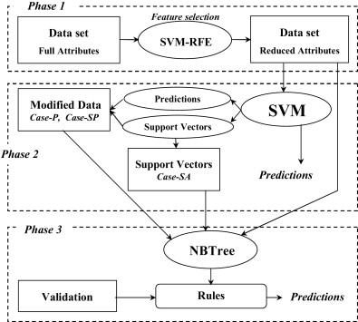

Results of Research

The results of this research present the machine learning modeling which founded on various algorithm such as logistic regression, decision tree, random forest, KNN, SVM classifier method. Variable selected from the dataset and feature selection applies on different machine learning strategies.
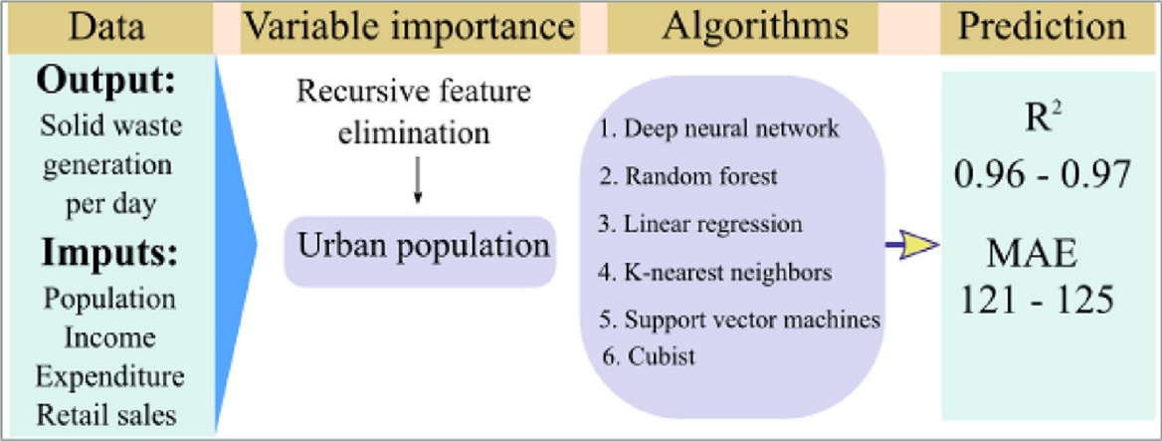
- K-Nearest Neighbor
- Gradient Boost Model
- Random Forest Model
- Decision Tree
- Support Vector machine
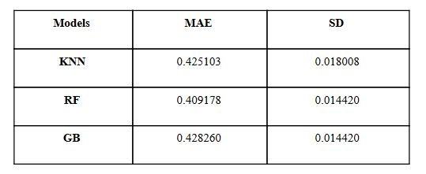

Sources of Research
The sources of research is carried by using the Jupyter notebook python programing IDE and ANACONDA tool. Other sources of data collection method based on IEEE Xplore, IEEE conference paper, MDPI Research paper including Google scholar’s research. Primary research data collected from Kaggle repository which is based on Rossmann sales store.
- Jupyter Notebook Anaconda Python
- IEEE
- ACM Digital library
- MDPI research
- Google Scholars
- Kaggle
- Github
- Python Machine learning libraries

Ethical Concern

The ethical concern of this research is primarily part to validate the research which is part of my own research, this is research purely part of my own research which is not copyright of other research work. This research does not harm any human being and any researcher during the findings of research, it’s primarily works of machine learning algorithm mainly deal with store sales prediction, this research does not conflict any goals and motives of other researcher, research is work going to predict and authenticate the retail stores sales and mart sales of Rossmann sales store chain, it is my own hard working effort that does not mean to validate to other researcher, this research is not part of funding agency and stakeholders to invest in this work to gain profit for retail store chain. Verification and validation process administered and carried out on the base of machine learning and deep learning algorithm discovery. The programming interface and coding part is not part of other researcher and previous publications. Ethically this research is respect to all the researcher and data science scholars to do the best in order to optimize the machine leaning method. Primary concern of this research is to supervise the research under the confidentiality of European rules and UK data government private concern. The moral values that harbors necessity follow towards remain the values of fairness, generosity, not at all maleficence, answerability, loyalty, independence, and then truth. Morals remain a scheme of ethical values then a division of attitude that describes pardon remains decent aimed at persons then civilization.

Chapter # 4 Results and Analysis

Machine learning method is part of data science application and artificial intelligence technique, various AI algorithm tested and applied in this chapter brief. 1st place solution is based on feature extraction, on recent dataset to validate key values of Rossmann store days of week, promotion, days, sales, time period and status of the sales which created on machine learning and statistical algorithm. Machine learning is subset of artificial intelligence which provides machines the ability to learn automatically and improve from experience without being explicitly programmed.

Feature Extraction

In dataset Days counter, how each record relates to events or cycles the number of days before after or within the events such as promotional cycle, summer holidays, store refurbishment, start of competition and start of secondary promote cycle within the store sales, number of holidays during the current week, last week and next week. Store specific linear model by training the dataset. Store features contain assortment, store type, aggregates by store, and average sales per customer, ratio of sales during promotions/holidays/Saturday sales.
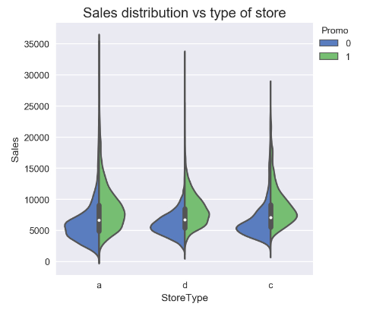
Figure: probability density function of sales with different store types and different promo options

Gradient Boosted Tree Model

Gradient boost is machine learning algorithm specially used for regression analysis, decision tree model constructed on Ada boost, tradeoff between bias and variance, and initialize model with constant value will return math function by boosting the model. Fit the regression tree founded on R value and regions of J value, when trying to predict a continuous value like weight, the first guess is the average value but unlike Ad boost, Ada boost and Gradient boost builds fixed sizes trees errors, but unlike Ada boost each tree can be larger than a stump. The term of pseudo residual is based on linear regression where the difference between the observed value and the predicted value results in residuals. Training and testing the dataset of various outlet of Rossmann stores in Europe. Model training XG Boost models on random selection of features, handpicked model, 500 random model and validate on each pair of ensembles model. Take features of all the selected model and combines into one. Separate models on the month May to Sep. Month ahead models, log transformed the variable, a multiplier factor (0.985) to apply.

KNN Algorithm

K Nearest neighbor algorithm which considered powerful machine learning algorithm which implementing in python programming, in 80% classification model in just 20% based on regression models, since the ratio of generalized machine learning models produce the nearest neighbor store locations which categorized on the given dataset of Rossmann store. The road map of k nearest neighbor approach interlinked with planes and coordinate plane lines and generate the neighbor stores which formulate on different items of interest of store target variables and make them assumption to produce the neighbor graphs of stores. The analytical method of k nearest neighbor generate graphs based on the target variable of interest and take them on validation after testing and training the dataset.

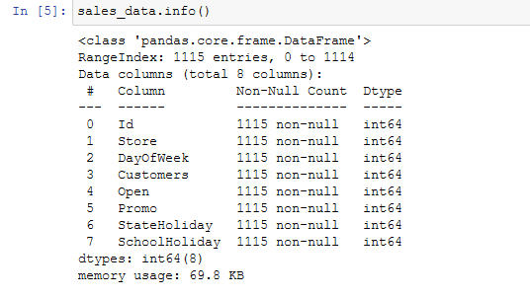
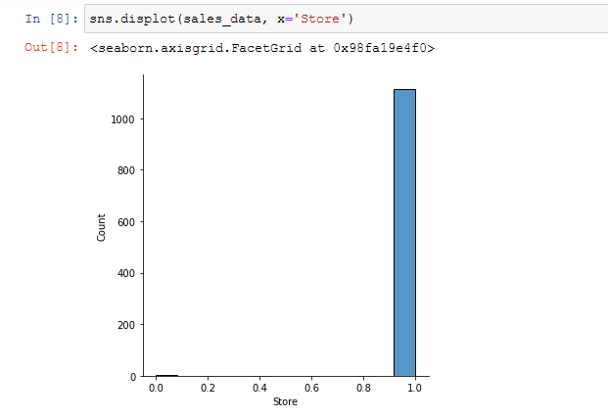
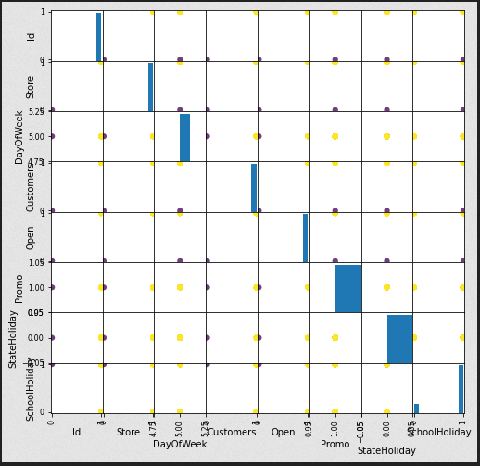

Support Vector Machine Classifier
Support vector machine solves the supervised machine learning algorithm, it is used to solve both classification regression problem statement, in classification problem to predict and categorize the statement of support vector machine classifier. We can easily separate the two classification points. Classify the certain point on hyper plane, logistic regression and linear regression the hyperplanes problem, support vector machine classifier make sure the hyperplanes line it also creates two marginal lines having some distance over there so that it easily linear separable for both the classification point. It was passing through the negative and positive points of hyperplanes. We also created two parallel planes one is dotted line the other one is also dotted line both the particular lines are parallel so make sure that atleast on of the nearest positive point. It’s created two hyperplanes in such way that one hyperplanes passing to the nearest positive point and the other hyperplanes passing towards the nearest negative point. When we computes the distance the deep positive and deep negative its whole distance basically known as marginal distance, generalized model in classification problem used the better accuracy of Rossmann store future sales any kind of dataset used as target variable of interest. SVM uses the kernel functions separated data by using the hyperplanes. SVM classify the nonlinear data transform the data into another dimensions. Hyperplanes check the distance between the support vectors and analyze the exact location of the vector planes.
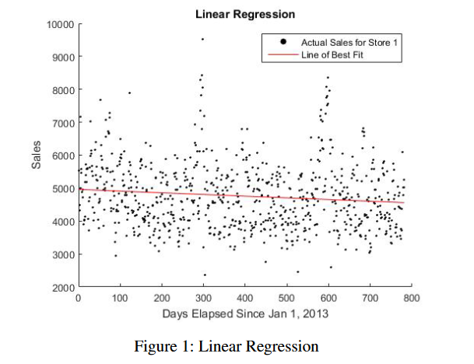
Figure: linear regression

Classification

Classification is about predicting a class discrete values such as future sales of store and past sale.

Regression

Regression is about predicting a quantity or continuous values such as week, month, and sales. Considering supervised machine learning method.

Workflow
- Dataset
- Data preprocessing
- Data analysis consist of train, test and split dataset
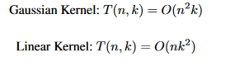

XG Boost Regression Classifier to predict Rossmann Store Future Prediction
Gradient method of XG boosting algorithm founded on machine learning algorithm prediction modeling, forecast of Rossmann store sales based on XG boost regression classifier model performed in python programing, since the Rossmann consider the super market chain of retail stores, the project studies sales of 1115 store sales dataset in recent three years performed the feature engineering from the dimension of space and time within the dataset values and build the prediction model, (Zhaoweijie, Chenliang, Hujiangmin 2020) XG boost algorithm based on gradient promotion algorithm which build the prediction model the forecast and sales volume of dataset of different Rossmann retail stores predict the next 48 days sales since the kaggle competition present the accuracy model of future sales about to 41088 samples features of data item reached the accuracy of 89.7%.
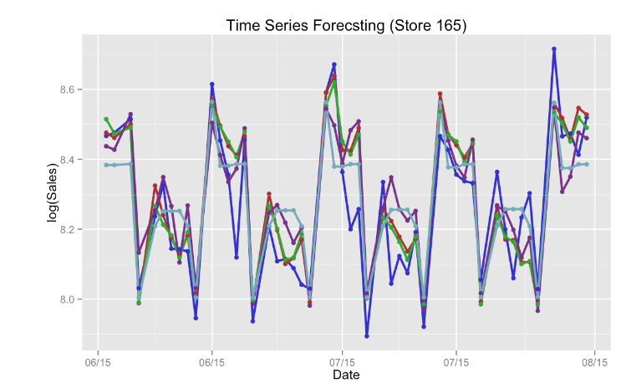
Figure: sales time series forecasting with different method

Importing dataset and python libraries
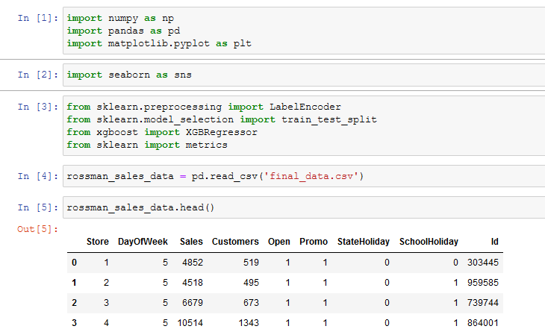

# Number of data point and number of features

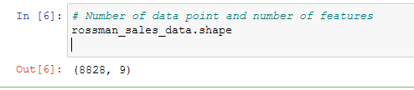

# getting some information about the dataset

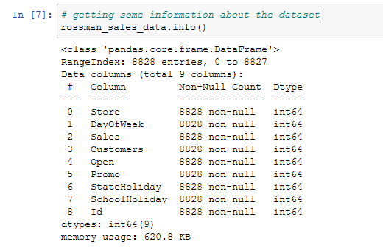

# Check missing values

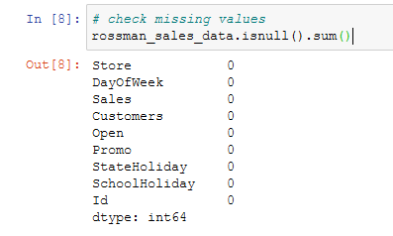

#statistical measures of dataset

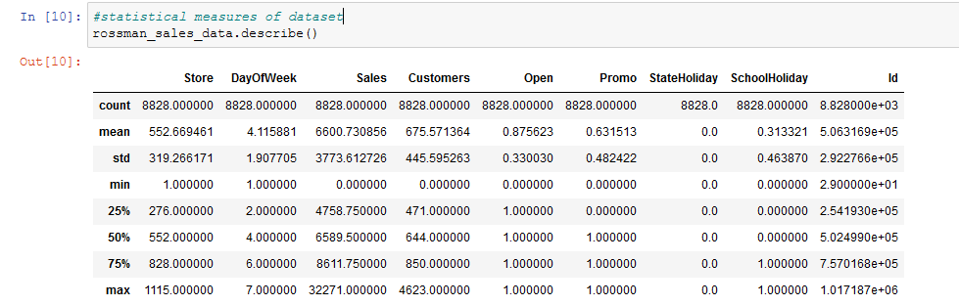

SNS Plot
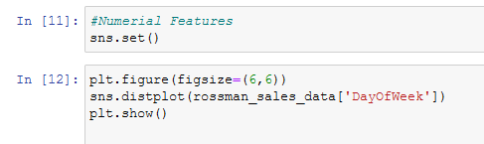
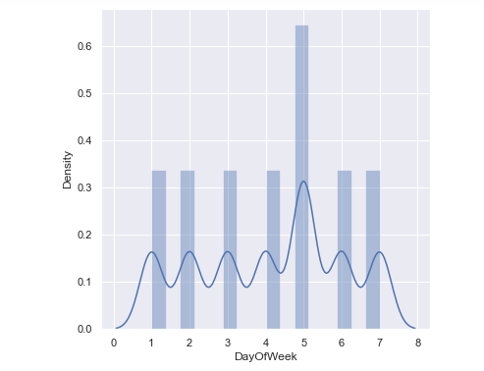
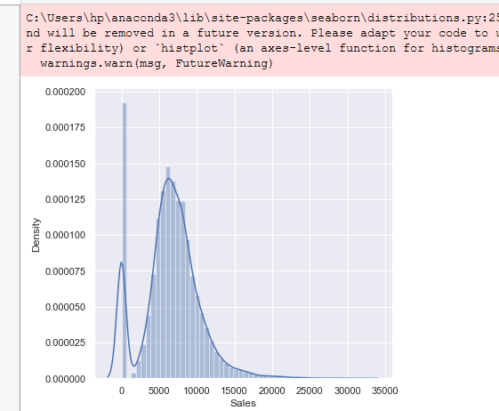
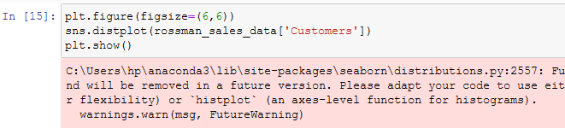
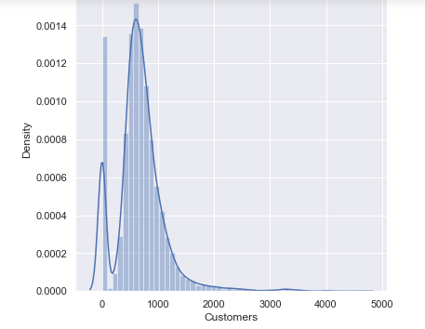
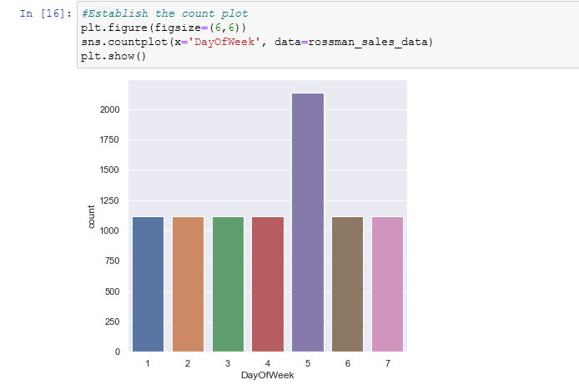
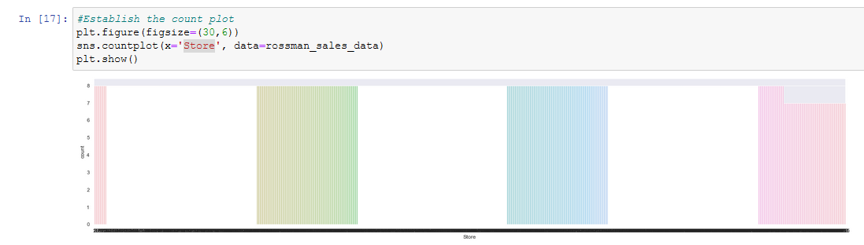

Days of week Value Counts
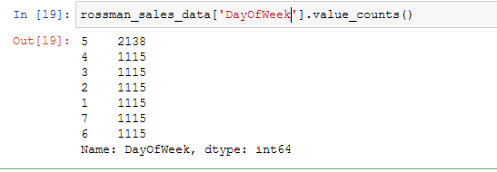

Label Encoder

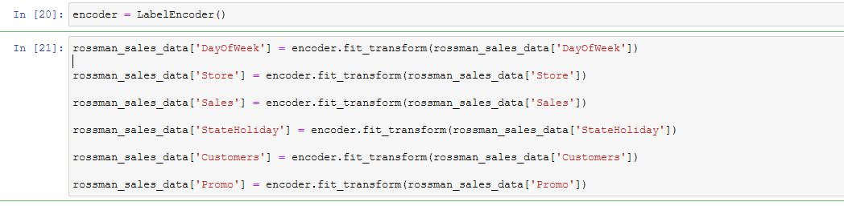

Dataset Head
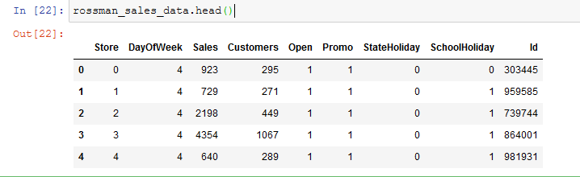
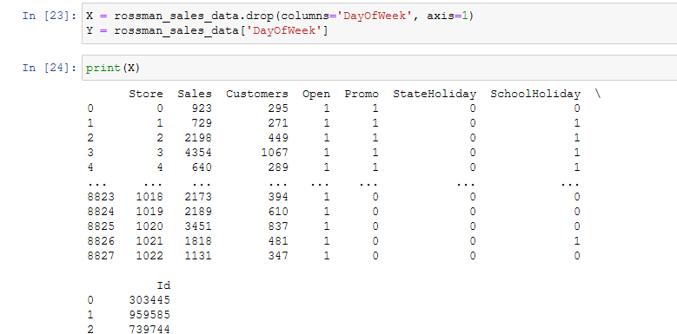
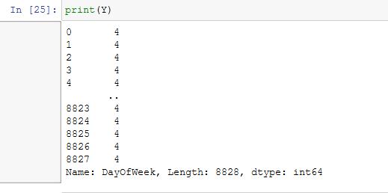

#Split the data into training and testing part

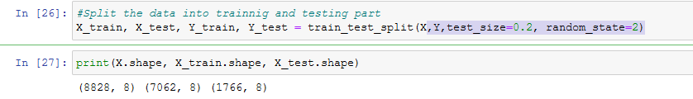

#XGBoost Regression of Machine Learning

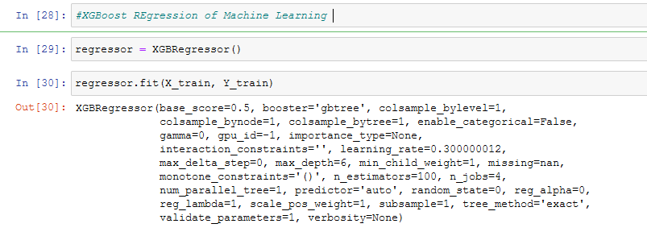

#predicted on training data # R squared value

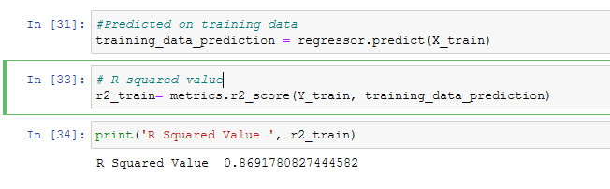

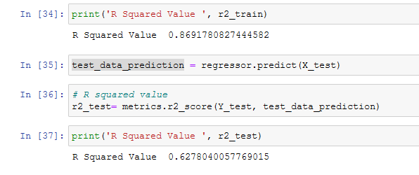

Results

Since the analysis part of covering the various factors of situation and solves the different forecasting problem, of Rossmann store sales random forest classifier uses the model of neural networks and classify the regression technique including the target values of validation based on target variable of research. Since the prediction forecasting present the model accuracy results based on the machine learning algorithm formulate in python programming it is important to note that the target variable selected by training and testing the dataset after feature selection of the variable from the given dataset, the conventional of cross validation approach split the historical data from splitting and testing the dataset so the training dataset approach split the dataset into two portion and selection feature which needs to extract the outcome, validation set of period selection from the days of week and target store locations sales which validate from the decision tree classifier and support vector machine learning classifier algorithm, since the selection of XG boost algorithms works effectively to produce the better outcome, the insight approach of kaggle Rossmann store competition and the company organized various machine learning classification method to get the highest accuracy results and in order to take decision from the investor and stakeholder to renovate the Rossmann stores and invest more after getting the advance future forecast sales graph. Since the 80,000 stores contains more than 1000 products on different category and simple python programing technique enables the researcher to formulate the consequences on graph based and analytical based to get the point of view on items of interest. The key stones of historical data structure analyzed the predictive sales analysis which depends on constructing new features and new sales forecasting outcomes to facilitate the business intelligence team of organization by taking the new initiative by experiences them and observe the new thing and business solution techniques. By creating the ensembles model of regression present this research in more advance order which gives us better accuracy in comparison with single model. This research sklearn python library constructing XG boost and linear regression classification technique to learn neural network deep learning approach to train and test the dataset for validation approach the target variable combines the aggregate features based on statistical score and graph including frequency features and target variable.

Decision Tree, Logistic Regression Support Vector Machine Classifier to predict Rossmann store sales

Importing dataset & libraries

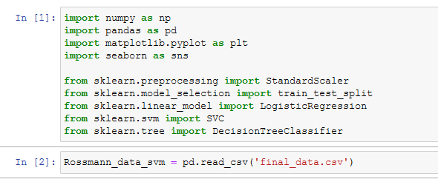

Dataset

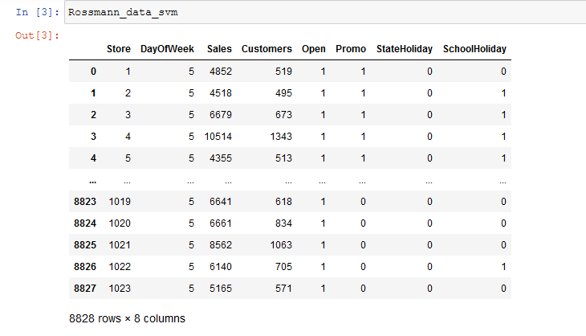

Dataset Features &Info

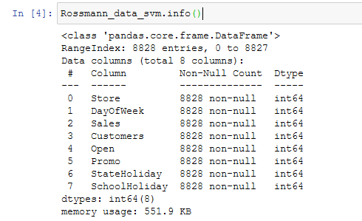

#Feature Engineering: Year & Month

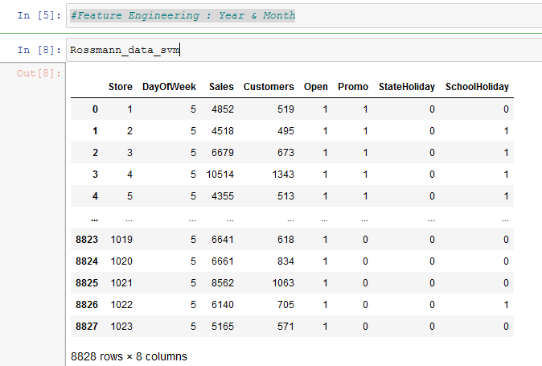

#Visualization Correlation
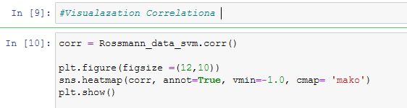
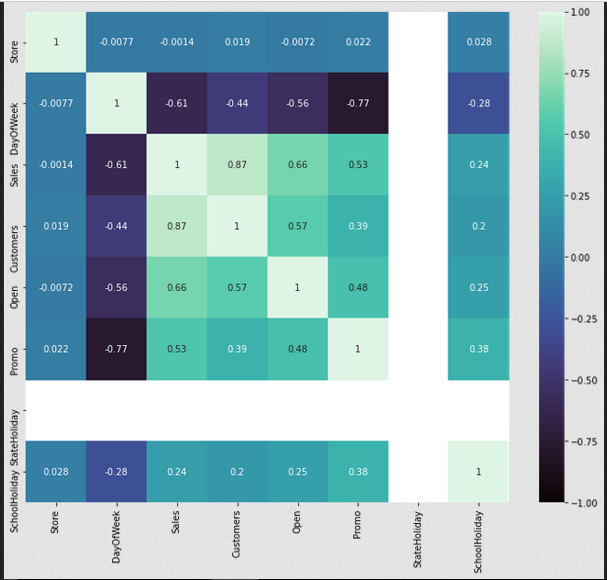

#Encoding Store column
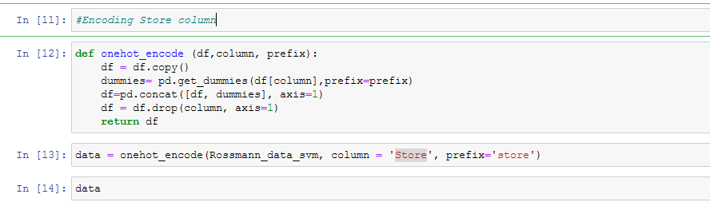
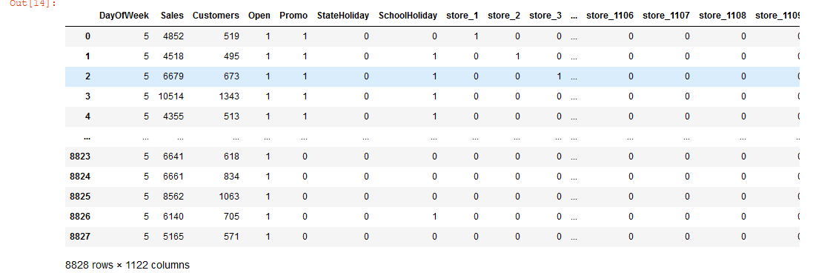

#Splitting Scaling
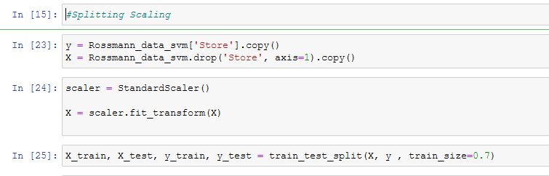

#Modeling & Training

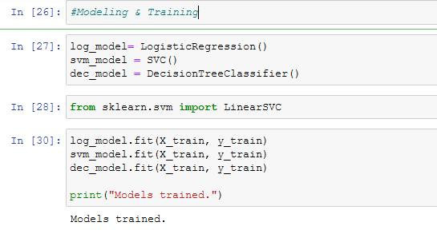

#Outcome
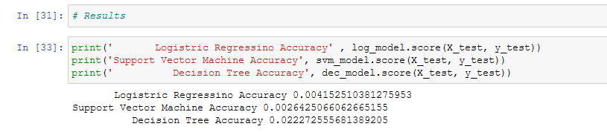

Decision Tree Analysis

Decision tree classification (Behera, G. Nain, N., 2019,) predict the retail store sales based on the accuracy model of machine learning algorithm, in these days big mart sales keep the track of retail sales of every individual item of sales which has been used to predict the future sales of the Rossmann store sales which required by the stakeholder. Machine learning prediction predict the future sales of Rossmann drug stores which was founded on different Europe location, its considered the largest drug chain stores predicting the future demands of sales which required by the management team to facilitate the customer and update the inventory management as well. The Rossmann store dataset contains large number of customer sales data based on different attributes of item which essentially used individual item as sales point of view at data warehousing projection. Additionally the anomalies and frequent pattern are detected by mining the dataset into decision tree classification technique, this research propose the XG Boost technique and other machine learning technique to predict and validate the future sales of Rossmann store, machine learning XG Boost and decision tree classifier produce the better accuracy detection result which compared with existing model, the comparative analysis of model is also explained. (Hwang, J., 2011) understanding Japanese tourist shopping preferences using the decision tree analysis method beside this research studies focused on Rossmann stores chain future sales prediction, the analytical method applied in this studies which was decision tree analysis classifier which utilize under the dataset of Rossmann store among the interesting findings of dataset present the future model and present the accuracy of highest precision call. Decision tree classifier models predict the shopping choice context as well which was based on the different choice of product category and it categories the different items of daily interest to choose and select from the dataset and put them on top priority based on the daily surface of the usages. The Japanese and Korean shopping retail stores based on the user choice and priority selection of product item which was based on the tourist shopping selection that was achieved to use the machine learning modeling.

Support Vector Machine Analysis

Investigation of this research present the future and present sales prediction and present the support vector machine classification accuracy (Lin, S., Yu, E. 2015) which achieve to predict the Rossmann store sales dataset, domain regression and support vector classification method for time series prediction of Rossmann store sales additionally the extent of data variable classified the provided support vector machine classifier based on forecasting of store sales. The resultant of regularization modeling founded on to predict and validate the production of dataset and items of interest. This research provided the 1115 store dataset located across Europe dataset records of each store and present with different attribute on numeric data value giving a total amount of 1 million data points, beside this the second part of dataset included additional information of model store with assortment of good sold product in presence of competition of store sales in Europe which was presented on Kaggle competition as well. The cross validation and data preprocessing has been performed in python notebook and calculated the accuracy as well.
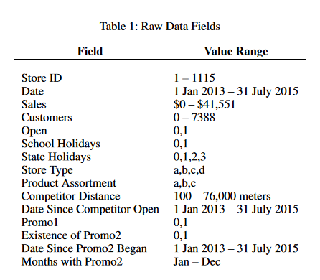
The extended period of times that used the data points and present the values of data prediction and availability of data items attributes which was only wants to access the algorithm predictive power on days when the store were open, the SVM model opted to remove the holidays days when the store was close from the dataset. Support vector machine classifier normalize the sales for each store and present them in accurate order in different time frequency pattern with respect of weekly sales of each store from different location of Europe. The focused on support vector machine classifier subtract the means sales for each store from each member which was retained as parameter. Hence the retail store allows us to predict and validate the machine learning models made the numerical Boolean values of variables, the store sales excluded the special state holidays on the above mentioned each store sales and predict the actual weekly day’s sales and produce the model.
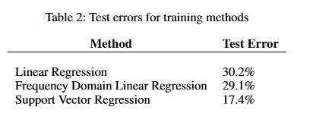

Logistic Regression Analysis

Machine learning modeling (Shwartz-Ziv, R., Armon, A., 2022) used to predict the future sales of Rossmann store, the ensembles model of XGBoost are typically suggested for classification and regression problem to solves the forecast situation over the use of dataset, deep learning modeling used the tabular data to classify the problem which claiming the performance analysis of future sales based on different variation of dataset attribute. Logistic regression modeling using the parameter of machine learning technique to enhance the accuracy rates of prediction, to perform the logistic regression model the dependent variable of research present the target variable of interest which formulate and validate the regression analysis Logistic regression implemented with linear regression technique including support vector machine classifier and decision tree classifier method and the model accuracy present with highest accuracy rates of future sales prediction which needs to formulate and design the research target. In some situation logistic regression might be difficult to implement, in quantitative research method it process with numerical float dataset to produces the outcome (Pavlyshenko, B.M., 2018) prediction of time series analysis to predict the future sales forecast and helps them to invest more and take break to invest which needs essential machine learning prediction analysis. Since the sales prediction is essential component of every business and modern business intelligence solution beside this the prediction of time series sales the conventional forecasting method of ARIMA and SARIAM which needs more improvement accuracy of future sales prediction, the multi-level approach of dataset constructed on daily/weekly/monthly and yearly present the seasonality approach with various factors of implicit sales in context of different time period. The implementation of over fitting which takes the feature extraction on part of target variable in some real cases of store sales which needs efficient number of historical sales of time series values formulate on recently open Rossmann store at different region, since the sales prediction hard to solves but by using the effective machine learning approach to get the highest prediction accuracy which needs more training and testing by selecting dataset feature. Various historical sales implemented on different kinds of sales attribute which based on store number and store location.
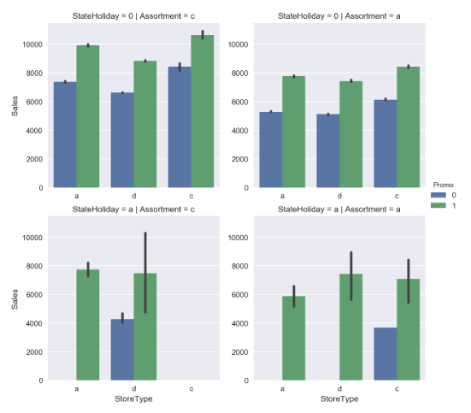
Figure: factor plot for sales

Analysis & Conclusion

Rossmann stores sales prediction using the machine learning model approaches (Gayathridevi, S. Naveen, P., 2021) various successful business including several factor which considered the different variation of sales and prediction the sales item of various store, retail stores chain product prediction was made on sales and product based on various retail store category sales forecasting of Rossmann stores sales predict with machine learning modeling, store sales predicting and analyzing the customer purchasing behavior and plays the modern business intelligence technique, forecasting of future sales predicting the future sales and which support the investor and business manager to takes decision on time and invest more in the retail stores chains founded on the machine learning analysis. Forecasting of future sales demands the business planning activities which formulate the overall business structure based on the previous experiences and drawbacks, forecasting helps various business organization to improves their business goals and change the business policies and parameters which reflect the sales business plans and to provide the stock storage solution, business sales forecasting analysis formulate and transform the dataset present in accurate model which needs additional formulation based on target variable and the data & information from past works considered the recognize feature selection. Sales forecasting helps in strategic planning of Rossmann stores stakeholder and investor which required to improve the retail store infrastructure and invest in opening of more retail stores chains in other countries. Additionally the sales forecasting helps the companies to taking decision on time and run more productively and efficiently, the strategic planning in marketing strategy which perform the overall past experiences roles attribute assess the past data and present the sales statistics report and predict the potential results of the sales on entire month. In this proposed research study the linear regression XG Boost and logistic regression model including support vector machine classifier, decision tee classifier modeling which formulates the results based on the trained and test the given dataset, sales forecasting helps the stakeholder to invest more in the retail chain stores opening and take decision to renovate the stores before time. The dataset is processed for feature selection and feature engineering and extract the required features of target variable of research. The accuracy results at the end present the dataset accuracy for building the machine learning models in the entire discussion of sales and forecasting, precise forecasts brand the situation calmer aimed at the workshop toward improvement request development then an advanced grade of auctions cohort. The situation produces healthier forecast degree. Future research required to improve the machine learning model by selection the features from the given dataset, and improve the prediction accuracy of the future sales of Rossmann store sales chain. Primary dataset is part of kaggle repository and in this research python programing has been deployed with various machine learning functionality and tools. Beside this research does not harm any researcher and it’s not part of any funding agency.

Chapter # 5 Discussion & Conclusion

Artificial neural network models build decision tree and regression analysis to calculate the interaction factors by generating the comparable results. (Behera, Nain, N., 2019) in these days shopping males and big mart keep track their sales data for individual variable of interest to estimate the predicting future demands of the clients and apprise the record running system by using the sentiment product analysis. Stores data consist of large number of customer on individual data items attributes based on the different product category, particularly the anomalies of data item detected on different data variable attributes and data items. Additionally the calculation of future sales and revenue surplus estimated on previous dataset forecast by using the machine learning technique, the predictive models using the XGBoost technique to expect the auctions business like large market (Punam, K. P.K., 2018) two level statistical models to analyze the big market sales trends of various organization engaging in retailing logistic, manufacturing and marketing wholesaling, sales and revenue plans organized on machine learning pattern to plans better strategy of future growth. Data exploration and data classification method has been analyzed and predicted which is founded on testing and training method to train the dataset and predict the variable of interest single model predictive learning algorithm approach on big mart sales data. (Sekban, J., 2019) to build efficient machine learning algorithm which is essentially works very well to do the sale forecasting and applying in on various dataset samples of sales. (Pavlyshenko, B., 2018) usages of stacking approaches for building ensembles of machine learning models, which is essentially used to deploy time series forecasting and logistic regression models by usages of stacking technique which is need to improve the performance of predictive models to considered the finance dataset and sales store dataset of reputed mart, the report has been to present the prediction based forecasting which was essentially tool to analyze and predict the various framework of stores. (Hegde, C., 2018) retail stores sales forecasting analyzed and predicted by using the machine learning models, the dataset size was very huge, which was not able to analyze them directly without data mining technique, this research present retail stores sales forecasting by using various machine learning technique to solves the various particular problem in which the dataset has been analyzed and predicted, implementation of normal regression technique which has been used to boosting the algorithm for producing the better algorithm results. (Wu, C.S.M. Gunaseelan, S., 2018) comparison of machine learning algorithm technique also applied to view the comparison results of different regression models, comparison of black Friday sales data which eventually produce the better profit results outcomes which was essentially based on multiple machine learning models regression, various machine learning method has been carried out to produce the better outcomes of machine learning modeling, to analyze the present and future sales prediction, research present that regression and neural network approach is better approach for finding the better outcomes of sales data predictions modeling, comparison has been done by analyzing the frequency score and accuracy prediction, the weekend sales data and weekdays sales data comparison has been made on dividing the dataset into two different groups and with the help of data preprocessing method which was essential tool of machine learning modeling, and data visualization technique is better way to produce the outcomes. The retail stores and commercial mart data has been merged into one dataset and prepared the dataset in one list and by training and testing phase the dataset is divided them before implementing the machine learning prediction models, training and testing present the feature selection of dataset which was essentials ways to analyze and group the dataset (Ramasubbareddy, S., Srinivas, 2021) sales analysis of back Friday weekend sales which was essentially ways to predict and analyze the dataset forecasting in which various framework has been analyzed and predicted on product category and product visualization, the dataset has been analyzed and predicted on demands frequency of various tools and technique method. Neural network classifier models analyzed and predict the black Friday sales and weekdays sales, the sales predicted on different price discounts and product category discount rates, in which the product category identified and predicted most common product of data items of interest. It was very hard to choose the product for the client but with the strong arguments and strong commitments the dataset has been predicted and analyzed on machine learning models the focusing of imminent clients constrained the staff and shop propertied to control and group the staff sales. Dataset models predicted the various data sales items in which the data items and product items carried out sufficient results, by extracting the future feature selection in testing and training part of dataset. Regression method and neural network modeling method was best approach to analyze and handle the dataset and predict the finance surplus and predict the future finance surplus. Machine learning technique was most effective technique to handle weekend’s sales prediction and weekday’s sales prediction of retails stores and merechdizer store. (Wisesa, O., Adriansyah, A. 2020) prediction sales of corporate services for telecommunication networks using the gradient boost algorithm the analysis of business sales data for business to business sales data prediction dataset has been analyzed and predicted on various sales forecasting of business to business sales surplus, telecommunication networks companies analyzed and predicted to increase the market growth by implementing the comprehensive sales prediction models of market which was analyzed and predict on different items and dataset. The projection of dataset analysis estimated and summarized in terms of reliability analysis to generate the accurate and exact forecasting data on different validation of data items of interest. Projection estimation analysis finding on different items of interest, the dataset forecasting of effective data forecasting results valuable resource of data forecasting resource sales data interact, the gradient boost algorithm shows the good accuracy of forecasting of sales data and future to business to business sales prediction of MSE 24,743,000,000.00, and MAPE: 0.18. (William De Luca, E., 2020) prediction employees abrasion using the machine learning technique, artificial intelligence method is one of the best essential method to predict and analyze the business strategies and analyze them the business features and customer feedback and reliability.

References
da Silva, R.G., Ribeiro, M.H.D.M., Larcher, J.H.K., Mariani, V.C. and dos Santos Coelho, L., Artificial Intelligence and Signal Decomposition Approach Applied to Retail Sales Forecasting. Training, 3981(6,675.03), pp.11-847.

Li, Z., Zhong, X. and Cui, Z., 2018, March. Evaluating forecasting algorithm of realistic datasets based on machine learning. In Proceedings of the 2nd International Conference on Innovation in Artificial Intelligence (pp. 72-76).

Wu, X., Shi, B., Dong, Y., Huang, C., Faust, L. and Chawla, N.V., 2018, October. Restful: Resolution-aware forecasting of behavioral time series data. In Proceedings of the 27th ACM International Conference on Information and Knowledge Management (pp. 1073-1082).

Kohli, S., Godwin, G.T. and Urolagin, S., 2021. Sales prediction using linear and KNN regression. In Advances in Machine Learning and Computational Intelligence (pp. 321-329). Springer, Singapore.

Weng, T., Liu, W. and Xiao, J., 2019. Supply chain sales forecasting based on lightGBM and LSTM combination model. Industrial Management & Data Systems.

Gurnani, M., Korke, Y., Shah, P., Udmale, S., Sambhe, V. and Bhirud, S., 2017, February. Forecasting of sales by using fusion of machine learning techniques. In 2017 International Conference on Data Management, Analytics and Innovation (ICDMAI) (pp. 93-101). IEEE.

Böse, J.H., Flunkert, V., Gasthaus, J., Januschowski, T., Lange, D., Salinas, D., Schelter, S., Seeger, M. and Wang, Y., 2017. Probabilistic demand forecasting at scale. Proceedings of the VLDB Endowment, 10(12), pp.1694-1705.

Ozyegen, O., Ilic, I. and Cevik, M., 2020. Evaluation of local explanation methods for multivariate time series forecasting. arXiv preprint arXiv:2009.09092.

Oner, M. and Ustundag, A., 2020. Combining predictive base models using deep ensemble learning. Journal of Intelligent & Fuzzy Systems, 39(5), pp.6657-6668.

Cheriyan, S., Ibrahim, S., Mohanan, S. and Treesa, S., 2018, August. Intelligent Sales Prediction Using Machine Learning Techniques. In 2018 International Conference on Computing, Electronics & Communications Engineering (iCCECE) (pp. 53-58). IEEE.

Kaneko, Y. and Yada, K., 2016, December. A deep learning approach for the prediction of retail store sales. In 2016 IEEE 16th International Conference on Data Mining Workshops (ICDMW) (pp. 531-537). IEEE.

Tsoumakas, G., 2019. A survey of machine learning techniques for food sales prediction. Artificial Intelligence Review, 52(1), pp.441-447.

Choi, J., Yang, H. and Oh, H., 2021. Store Sales Prediction Using Gradient Boosting Model. Journal of the Korea Institute of Information and Communication Engineering, 25(2), pp.171-177.

Pavlyshenko, B.M., 2019. Machine-learning models for sales time series forecasting. Data, 4(1), p.15.

Kohli, S., Godwin, G.T. and Urolagin, S., 2021. Sales Prediction Using Linear and KNN Regression. In Advances in Machine Learning and Computational Intelligence (pp. 321-329). Springer, Singapore.

Sharma, S.K., Chakraborti, S. and Jha, T., 2019. Analysis of book sales prediction at Amazon marketplace in India: a machine learning approach. Information Systems and e-Business Management, 17(2), pp.261-284.

Behera, G. and Nain, N., 2019, September. A Comparative Study of Big Mart Sales Prediction. In CVIP (1) (pp. 421-432).

Punam, K., Pamula, R. and Jain, P.K., 2018, September. A two-level statistical model for big mart sales prediction. In 2018 International Conference on Computing, Power and Communication Technologies (GUCON) (pp. 617-620). IEEE.

Sekban, J., 2019. Applying machine learning algorithms in sales prediction.

Pavlyshenko, B., 2018, August. Using stacking approaches for machine learning models. In 2018 IEEE Second International Conference on Data Stream Mining & Processing (DSMP) (pp. 255-258). IEEE.

Krishna, A., Akhilesh, V., Aich, A. and Hegde, C., 2018, December. Sales-forecasting of retail stores using machine learning techniques. In 2018 3rd International Conference on Computational Systems and Information Technology for Sustainable Solutions (CSITSS) (pp. 160-166). IEEE.

Wu, C.S.M., Patil, P. and Gunaseelan, S., 2018, November. Comparison of different machine learning algorithms for multiple regression on black friday sales data. In 2018 IEEE 9th International Conference on Software Engineering and Service Science (ICSESS) (pp. 16-20). IEEE.

Ramasubbareddy, S., Srinivas, T.A.S., Govinda, K. and Swetha, E., 2021. Sales Analysis on Back Friday Using Machine Learning Techniques. In Intelligent System Design (pp. 313-319). Springer, Singapore.

Wisesa, O., Adriansyah, A. and Khalaf, O.I., 2020, September. Prediction analysis sales for corporate services telecommunications company using gradient boost algorithm. In 2020 2nd International Conference on Broadband Communications, Wireless Sensors and Powering (BCWSP) (pp. 101-106). IEEE.

Fallucchi, F., Coladangelo, M., Giuliano, R. and William De Luca, E., 2020. Predicting employee attrition using machine learning techniques. Computers, 9(4), p.86.

E Tarallo, GK Akabane, CI Shimabukuro, J Mello… - IFAC-PapersOnLine, 2019 – Elsevier
Kim, C.E., Oghaz, M.M.D., Fajtl, J., Argyriou, V. and Remagnino, P., 2018. A comparison of embedded deep learning methods for person detection. arXiv preprint arXiv:1812.03451.

Hossain S.M.S., Rawat J., Logofatu D. (2021) Analysis and Prediction for House Sales Prices by Using Hybrid Machine Learning Approaches. In: Maglogiannis I., Macintyre J., Iliadis L. (eds) Artificial Intelligence Applications and Innovations. AIAI 2021. IFIP Advances in Information and Communication Technology, vol 627. Springer, Cham. https://doi.org/10.1007/978-3-030-79150-6_47

Using machine learning algorithms for housing price prediction: Byeonghwa Parka Jae KwonBae 2015 The case of Fairfax County, Virginia housing data Expert Systems with Applications Volume 42, Issue 6, 15 April 2015, Pages 2928-2934

Predicting Sales Prices of the Houses Using Regression Methods of Machine Learning Parasich Andrey Viktorovich; Parasich Viktor Aleksandrovich 2018 3rd Russian-Pacific Conference IEEE

Behera, G., Bhoi, A.K. and Bhoi, A., 2021. UHWSF: univariate holt winter’s based store sales forecasting. In Intelligent Systems (pp. 283-292). Springer, Singapore.

Sun, W. and Liu, M., 2016. Prediction and analysis of the three major industries and residential consumption CO2 emissions based on least squares support vector machine in China. Journal of Cleaner Production, 122, pp.144-153.

Bala, P.K., 2010, December. Decision tree based demand forecasts for improving inventory performance. In 2010 IEEE International Conference on Industrial Engineering and Engineering Management (pp. 1926-1930). IEEE.

Gopalakrishnan, T., Choudhary, R. and Prasad, S., 2018, December. Prediction of Sales Value in Online shopping using Linear Regression. In 2018 4th International Conference on Computing Communication and Automation (ICCCA) (pp. 1-6). IEEE.

Ekambaram, V., Manglik, K., Mukherjee, S., Sajja, S.S.K., Dwivedi, S. and Raykar, V., 2020, August. Attention based multi-modal new product sales time-series forecasting. In Proceedings of the 26th ACM SIGKDD International Conference on Knowledge Discovery & Data Mining (pp. 3110-3118).

Shaukat, K., Luo, S., Abbas, N., Mahboob Alam, T., Ehtesham Tahir, M. and Hameed, I.A., 2021, January. An analysis of blessed Friday sale at a retail store using classification models. In 2021 The 4th International Conference on Software Engineering and Information Management (pp. 193-198).

Massaro, A., Maritati, V. and Galiano, A., 2018. Data Mining model performance of sales predictive algorithms based on RapidMiner workflows. AIRCC's International Journal of Computer Science and Information Technology, 10(3), pp.39-56.

Odegua, R., 2020. Applied Machine Learning for Supermarket Sales Prediction. Project: Predictive Machine Learning in Industry.

GÜVEN, İ., UYGUN, Ö. and ŞİMŞİR, F., 2021. Machine Learning Algorithms with Intermittent Demand Forecasting: An Application in Retail Apparel with Plenty of Predictors. Textile and Apparel, 31(2), pp.99-110.

Behera, G. and Nain, N., 2019, September. A comparative study of big mart sales prediction. In International Conference on Computer Vision and Image Processing (pp. 421-432). Springer, Singapore.

Kim, S.S., Timothy, D.J. and Hwang, J., 2011. Understanding Japanese tourists’ shopping preferences using the Decision Tree Analysis method. Tourism management, 32(3), pp.544-554.

Lin, S., Yu, E. and Guo, X., Forecasting Rossmann Store Leading 6-month Sales. 2015

Zhaoweijie, Chenliang and Hujiangmin, "Forecast Rossmann Store Sales Base on Xgboost Model," in 2020 2nd International Conference on Economic Management and Model Engineering (ICEMME), Chongqing, China, 2020 pp. 521-525.

Saraswathi, K., Renukadevi, N.T., Nandhinidevi, S., Gayathridevi, S. and Naveen, P., 2021, November. Sales prediction using machine learning approaches. In AIP Conference Proceedings (Vol. 2387, No. 1, p. 140038). AIP Publishing LLC.

Shwartz-Ziv, R. and Armon, A., 2022. Tabular data: Deep learning is not all you need. Information Fusion, 81, pp.84-90.

Pavlyshenko, B.M., Predictive Analytics for Sales Time Series. International Scientific and Practical Conference "Electronics and Information Technologies" (ELIT-2018)

Carbonneau, R., Laframboise, K. and Vahidov, R., 2008. Application of machine learning techniques for supply chain demand forecasting. European Journal of Operational Research, 184(3), pp.1140-1154.

Tanizaki, T., Hoshino, T., Shimmura, T. and Takenaka, T., 2019. Demand forecasting in restaurants using machine learning and statistical analysis. Procedia CIRP, 79, pp.679-683.

Huber, J. and Stuckenschmidt, H., 2020. Daily retail demand forecasting using machine learning with emphasis on calendric special days. International Journal of Forecasting, 36(4), pp.1420-1438.

Zuo, Y., Yada, K. and Ali, A.S., 2016, December. Prediction of consumer purchasing in a grocery store using machine learning techniques. In 2016 3rd Asia-Pacific World Congress on Computer Science and Engineering (APWC on CSE) (pp. 18-25). IEEE.

Žliobaitė, I., Bakker, J. and Pechenizkiy, M., 2012. Beating the baseline prediction in food sales: How intelligent an intelligent predictor is?. Expert Systems with Applications, 39(1), pp.806-815.

Güven, İ. and Şimşir, F., 2020. Demand forecasting with color parameter in retail apparel industry using artificial neural networks (ANN) and support vector machines (SVM) methods. Computers & Industrial Engineering, 147, p.106678.

Loureiro, A.L., Miguéis, V.L. and da Silva, L.F., 2018. Exploring the use of deep neural networks for sales forecasting in fashion retail. Decision Support Systems, 114, pp.81-93.

